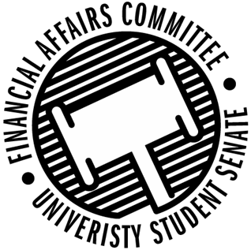

Meeting Agenda
3:30 PM Willow/Walnut Room, Memorial Student Center
50th Congress September 20th, 2019
- Call to Order
- Roll Call
April 12, 2019 | Present | Absent | Excused
Director Gentz
Senator Dumke
Senator Halbach
Senator Penoske
Advisor Lee

- Words of Wisdom
- Open Forum
  - Training
- Approval of the Minutes
  - 4-12-19
- Unfinished Business
- New Business
  - Vice Chair Election Information
  - Reallocation Request
    - Fishing Club
    - Men’s Soccer
    - Sports Clubs Commission
    - International Game Developers Association
    - Institute of Real Estate Management
  - Contingency I
- Announcements
- Adjourn

