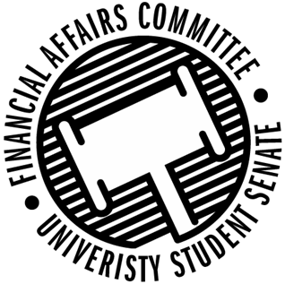

Meeting Agenda
3:30 PM White Pine Room, Memorial Student Center
50th Congress October 25th, 2019
- Call to Order
- Roll Call
April 12, 2019 | Present | Absent | Excused
Director Gentz | X
Vice Chair Halbach | X
Senator Dumke | X
Senator Penoske | X
Advisor Lee |  |  | X

- Words of Wisdom
  - Senator Dumke
    - The universe is a cruel uncaring void. The key to being happy isn’t a search for meaning, its’s to just keep yourself busy with unimportant nonsense, and eventually, you’ll be dead.” – Mister Peanutbutter
    - Senator Penoske next week.
- Approval of the Minutes
  - 10-18-19
  - Approved 3-0-0
- Unfinished Business
  - Contingency I Rules
    - Moved to Approve by Halbach, 2nd by Penoske
    - Approved 3-0-0
- New Business
  - Reallocation Requests
    - ISP
      - Moved to Deny by Penoske, 2nd by Halbach
      - Approved denial 3-0-0
    - Society of Manufacturing Engineers
      - Moved to Approve by Dumke, 2nd by Penoske
      - Approved 3-0-0
  - Contingency I Deliberations
    - Approved Unless Noted Below
      - HSMAI
        - Moved the previous question by Dumke, 2nd by Penoske
        - Denied 1-1-0
        - The Chair determined the nays have it
        - HSMAI did not attend hearing
      - IREM
        - Can only approve up to $50 for registration per person
        - Cannot fund anything for an advisor
      - Wrestling Club
        - Rental mat not funded as we funded up to cap for their own mat sections.
      - Women’s Ice Hockey
        - Registration approved up to member cap
        - Used number of members based off Connect page
      - ASME
        - Postponed their budget for further information
        - Questions about equipment and event supplies
      - YETI
        - Events denied because they occur outside of the Contingency 1 process.
        - Speaker denied because it is outside the mission of the organization
      - BAJA
        - Cannot fund cash prizes
        - Porta-potty voted on because it is a for profit event
        - 1-1-1
        - Chair sided with nays
      - ASBMB
        - Lab Coats were determined to be personal gain which we cannot fund.
      - Her Campus
        - Did not fund the film rights because the committee determined it was not within the mission of the org.
- Announcements
  - Senator Dumke wants to investigate Prize Money rules.
  - POSSIBLE NEW MEETING TIME!?!?!?!?!
    - Thinking about Monday 4:30 to 6:30
    - Think about alternatives.
- Adjourn
  - Chair adjourned against the will of the committee at 5:37 PM

