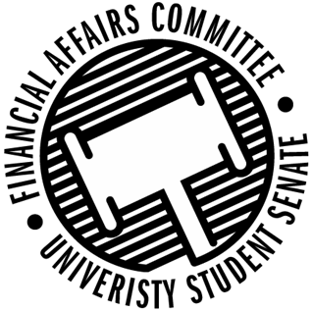

Meeting Agenda
4:30 PM Microsoft Teams Virtual Meeting
50th Congress March 30th, 2020
- Call to Order
- Roll Call
 | Present | Absent | Excused
Director Gentz
Vice Chair Halbach
Senator Dumke
Senator Kleinschmidt
Senator Korte
Senator Reindl
Advisor Lee

- Approval of the Agenda
- Approval of the Minutes
  - 3-9-2020
- Words of Wisdom
  - Senator Korte
- Unfinished Business
  - Contingency 3 Deliberations
    - School Counseling Organization
    - PCMA
    - PONG
- New Business
  - Annual Budget Appeal Deliberations
    - Fishing Club
    - Stout Typographical Society
- Announcements
- Adjourn

